EXPERIENCE NATURE AND ALL ITS WONDERS ALONG ENGLAND’S COAST
A paradise for lovers of flora and fauna

Amsterdam, March 25, 2019 - The English coastal regions have a lot to offer when it comes to flora and fauna. The wonderland for birdwatchers is a few hours away by boat or train from the Netherlands and offers a wide range of endless beaches, hiking trails, bustling port cities and amazing nature reserves. Compact, diverse and full of different animal species, the English coast is one of the best places to experience nature and all its wonders.

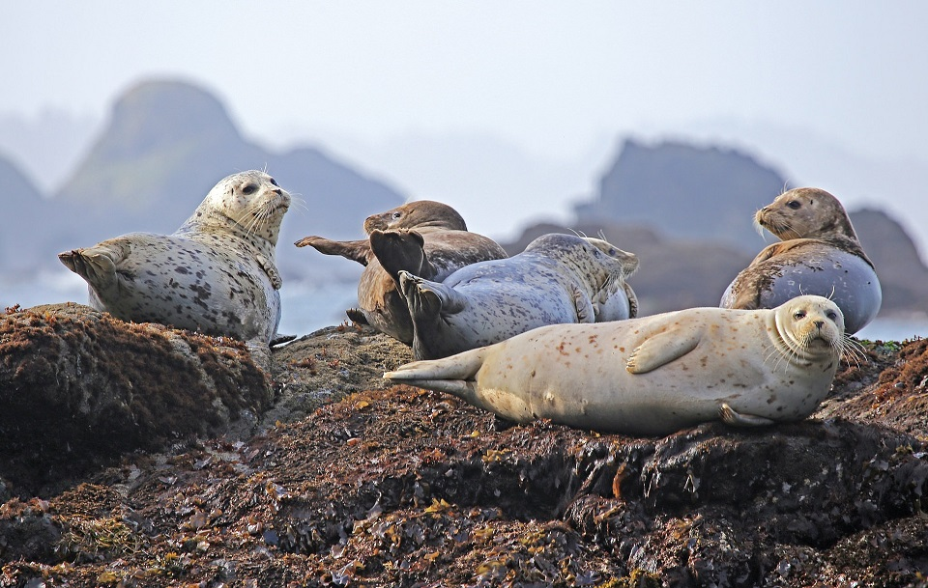

Get up close to seals!
Head to the east coast for amazing views of colonies of common and Atlantic grey seals. Take a two-hour seal-watching trip in the Walton Backwater, Essex, under the guidance of an experienced boatman and naturalist during the summer. While on board, you’ll encounter common and grey seals along with many other rare and beautiful birds and wildlife that live on the Hamford Water Nature Reserve.
While you’re in the area, why not go fossil hunting on the cliffs at Walton-on-the-Naze? They form one of the finest geological sites in Britain and for that reason are a Site of Special Scientific Interest (SSSI).
If you’re travelling on the north-east coast, the Northumberland Coast is one of the most important areas in Europe for the Atlantic grey seal and they can be seen at any time of the year, you’re also increasingly likely to spot dolphins and even whales.
Further south and within easy reach of The Netherlands, a boat trip from Blakeney Point in Norfolk is the ideal way for sights of grey and common seals.

Puffins on the Farne Islands
From Seahouses you can visit the seabird reserve on the Farne Islands by boat. This is home to many seabirds including puffins, auks, guillemots and shags. Nature is at its best at these unique bird areas on the east coast of northern England. Follow the promenades around the island and discover the rich variety of flora and fauna.

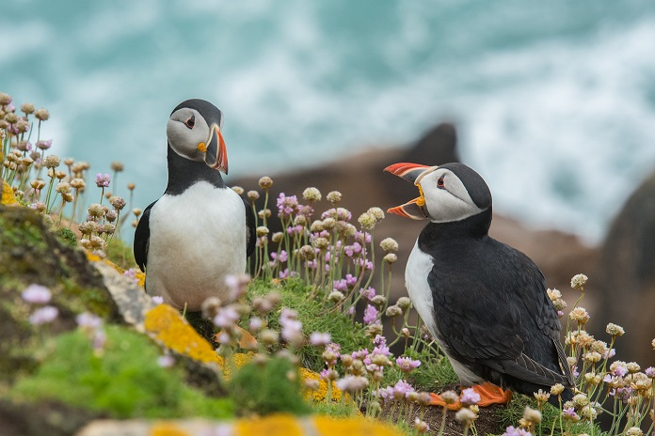

Migrating Geese
Seeing a flock of pink-footed geese fly above your head is one of the most stunning spectacles on our coastline. Choose from Gibraltar Point, Lincolnshire, Cley Marshes, Essex, or Spurn Nature Reserve in Yorkshire. On an autumn day of their choosing, the geese will take flight from Iceland (where they spend the summer) to the Faroe Islands, before heading on to the English coast. Unmissable!
Spot endangered red squirrels
Explore Dorset’s nature reserves to discover some special wildlife, here you’ll find everything from bluebells to barn owls, otters to orchids and deer to dolphins! While you’re in Dorset make sure you jump on a ferry from Poole Quay to Brownsea Island, a haven for wildlife. Red squirrels, almost extinct in Southern England, can be found here alongside Sika deer, peacocks and a range of birds including grey herons, little egrets, cormorants, oystercatchers, shelducks, kingfishers and wagtails.

Don’t miss the big cats!

Just north-west of the Norfolk seaside resort of Great Yarmouth, explore Thrigby Hall Wildlife Gardens where, through their conservation work, you can see a special collection of rare Asian animals including tigers, Amur leopards, reptiles and primates. The tiger walk gets you right up into the trees and really close to the big cats.

Ends/

For more information and images please contact Sheron Crossman, England’s Coast Marketing & Communications Manager Sheron.crossman@coastaltourismacademy.co.uk
The England’s Coast project is being run by the National Coastal Tourism Academy whose partners include P&O Ferries, Green Traveller, Visit Northumberland, Yorkshire Coast, Scarborough, North York Moors National Park, East Riding of Yorkshire, English Riviera, Teignbridge District Council, Kingsbridge and South Devon, Visit Cornwall, Visit Brighton, Eastbourne, Dorset County Council, Visit East Anglia, Suffolk Coast, Visit Hull and East Yorkshire, Visit North Norfolk, East Lindsey District Council, Bournemouth Borough Council.
About the Discover England Fund
- In November 2015, the Government announced a £40 million Discover England Fund; an unprecedented opportunity for English tourism. The Fund aims to deliver world-class bookable tourism products joined up across geographies and/or themes; including integrated transport solutions to provide an end-to-end customer experience.
- The Fund supports the growth of one of England’s most successful export industries, inbound tourism. Tourism is an industry that delivers jobs and economic growth across the English regions – contributing some £106bn each year to the economy and supporting 2.6 million jobs.
- The Fund supported a number of pilot projects in year one (2016/17) that tested product development approaches. In years two and three, 2017-19, the fund will support:
  - A number of large-scale collaborative projects to be delivered over the two year period 2017-2019 that will create a step-change in bookable English tourism product for international consumers,
  - A smaller funding pot for new one year pilot projects (in year two), and
  - Continuation funding for existing year one projects that demonstrated early learnings (in year two).
About VisitBritain/VisitEngland
- VisitBritain/VisitEngland is the national tourism agency – a non-departmental public body funded by the Department for Culture, Media & Sport (DCMS)

Working with a wide range of partners in both the UK and overseas, our mission is to grow the volume and value of inbound tourism across the nations and regions of Britain and to develop world-class English tourism product to support our growth aspirations. For further information and to access the latest in-depth market intelligence and statistics visit www.visitbritain.org or www.visitbritain.com and www.visitengland.com

